Contribution Title
First Author1[0000−1111−2222−3333], Second Author2,3[1111−2222−3333−4444], and Third Author3[2222−−3333−4444−5555]
- Princeton University, Princeton NJ 08544, USA
- Springer Heidelberg, Tiergartenstr. 17, 69121 Heidelberg, Germany
lncs@springer.com
http://www.springer.com/gp/computer-science/lncs
- ABC Institute, Rupert-Karls-University Heidelberg, Heidelberg, Germany
{abc,lncs}@uni-heidelberg.de
Abstract. The abstract should briefly summarize the contents of the paper in 150–250 words.
Keywords: First keyword · Second keyword · Another keyword.
- First Section
1.1 A Subsection Sample
Please note that the first paragraph of a section or subsection is not indented. The first paragraph that follows a table, figure, equation etc. does not need an indent, either.
Subsequent paragraphs, however, are indented.
Sample Heading (Third Level) Only two levels of headings should be numbered. Lower level headings remain unnumbered; they are formatted as run-in headings.
Sample Heading (Fourth Level) The contribution should contain no more than four levels of headings. Table 1 gives a summary of all heading levels.
Table 1. Table captions should be placed above the tables.
Heading level | Example | Font size and style
Title (centered) | Lecture Notes | 14 point, bold
1st-level heading | 1 Introduction | 12 point, bold
2nd-level heading | 2.1 Printing Area | 10 point, bold
3rd-level heading | Run-in Heading in Bold. Text follows | 10 point, bold
4th-level heading | Lowest Level Heading. Text follows | 10 point, italic
- F. Author et al.
Displayed equations are centered and set on a separate line.
x+y=z (1)
Please try to avoid rasterized images for line-art diagrams and schemas. Whenever possible, use vector graphics instead (see Fig. 1).
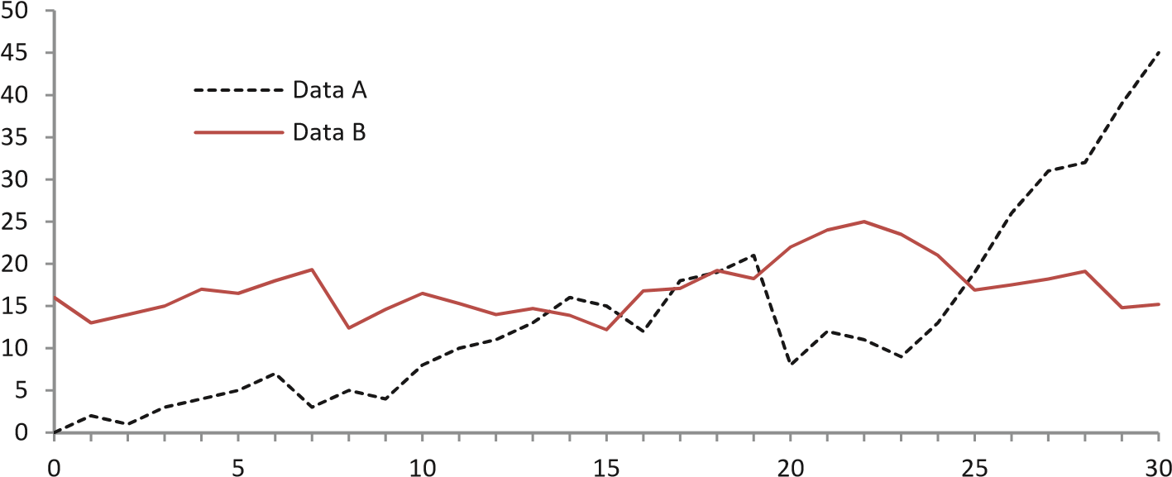
Fig.1. A figure caption is always placed below the illustration. Please note that short captions are centered, while long ones are justified by the macro package automatically.
Theorem 1. This is a sample theorem. The run-in heading is set in bold, while the following text appears in italics. Definitions, lemmas, propositions, and corollaries are styled the same way.
Proof. Proofs, examples, and remarks have the initial word in italics, while the following text appears in normal font.
For citations of references, we prefer the use of square brackets and consecutive numbers. Citations using labels or the author/year convention are also acceptable. The following bibliography provides a sample reference list with entries for journal articles [1], an LNCS chapter [2], a book [3], proceedings without editors [4], and a homepage [5]. Multiple citations are grouped [1–3], [1,3–5].
Conflict of Interest Examples:
- Dr. YYYYY serves as a consultant for Company X.
- Dr. XXXXX is an employee of Company Y.
- Dr. XXXXX owns stock in Company Z.
- All other authors have no conflicts of interest.
- If no author has a conflict, the statement should read “All authors have no conflicts of interest.
Contribution Title 3
Acknowledgements Please place your acknowledgments at the end of the paper, preceded by an unnumbered run-in heading (i.e. 3rd-level heading).
References
- Author, F.: Article title. Journal 2(5), 99–110 (2016)
- Author, F., Author, S.: Title of a proceedings paper. In: Editor, F., Editor, S.(eds.) CONFERENCE 2016, LNCS, vol. 9999, pp. 1–13. Springer, Heidelberg (2016). https://doi.org/10.10007/1234567890
- Author, F., Author, S., Author, T.: Book title. 2nd edn. Publisher, Location (1999)
- Author, A.-B.: Contribution title. In: 9th International Proceedings on Proceedings,pp. 1–2. Publisher, Location (2010)
- LNCS Homepage, http://www.springer.com/lncs. Last accessed 4 Oct 2017

Supported by organization x.

